Mr. Sabado, Algebra 2 Tuesday, October 29, 2013

Homework

Due Today:
Chapter 4 Test Review #2

Due 10/30:
Study for Chapter 4 Test Part 2: Sections 4.1-4.10


Presentations will be held Thursday and Friday.

Agenda

- Warm-Up

- HW Check

- Chapter 4 Test

- Quiet Activity

Warm-Up
- Where should the inequality 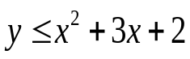 be shaded?
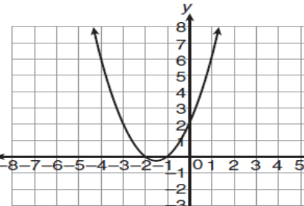
Solve by completing the square
2) 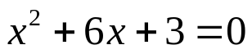

Simplify
2)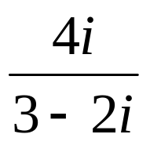
`
whs.saba.do



“It is never too late to be what you might have been.”
- G. Eliot

